Was Your Home Affected By The

Recent Severe Storms?

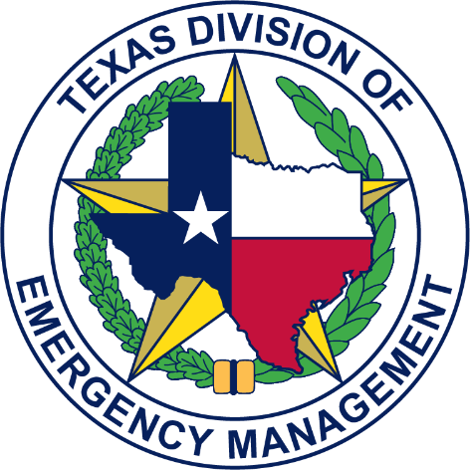
REPORT YOUR DAMAGES HERE:
Visit damage.tdem.texas.gov or
scan the QR code with your Smart Phone:
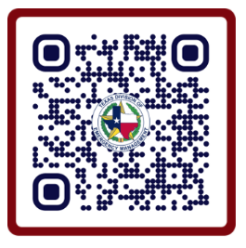
This survey will help state and local emergency management officials identify and gain an understanding of damages from the recent storms.

Reporting damages to Emergency Management is a voluntary activity, is not a substitute for reporting damage to your insurance agency, and does not guarantee disaster relief assistance.

